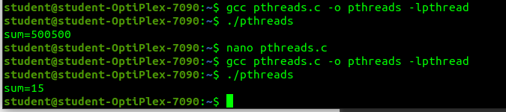
In lab code workout 1:
In lab code workout 2:
Before uncommenting:
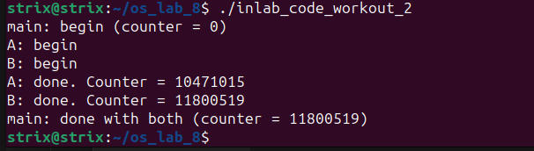
AFTER uncommenting:
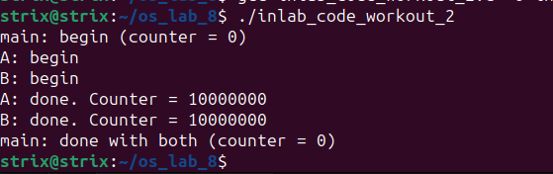

B) Both threads are calculating different values of counter due to the global declaration of counter variable as it is not resetting the counter variable once the thread ends.
C) Yes, now the value of counter is changed, both the threads are now printing the same value of counter due to reinitialization to 0 every time a new thread use that function.

IN lab Question 1a:

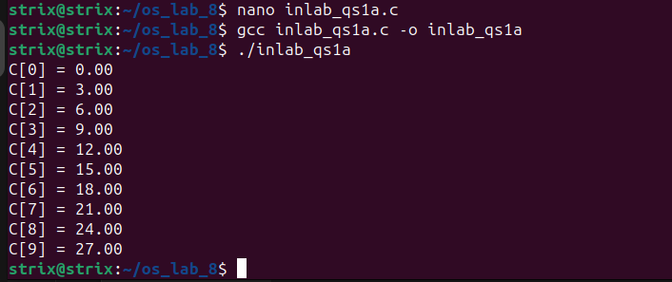

Code:
#include <stdio.h>
#include <stdlib.h>
#include <pthread.h>

#define ARRAY_SIZE 10000000

float A[ARRAY_SIZE];
float B[ARRAY_SIZE];
float C[ARRAY_SIZE];

void *thread_add(void *arg) {
for (int i = 0; i < ARRAY_SIZE; ++i) {
C[i] = A[i] + B[i];
}
pthread_exit(NULL);
}

int main() {
pthread_t thread;

for (int i = 0; i < ARRAY_SIZE; ++i) {
A[i] = i * 1.0;
B[i] = i * 2.0; // Just an example initialization
}

pthread_create(&thread, NULL, thread_add, NULL);

pthread_join(thread, NULL);

// Printing some elements of array C
for (int i = 0; i < 10; ++i) {
printf("C[%d] = %.2f\n", i, C[i]);
}

return 0;
}
IN lab Question 1b:

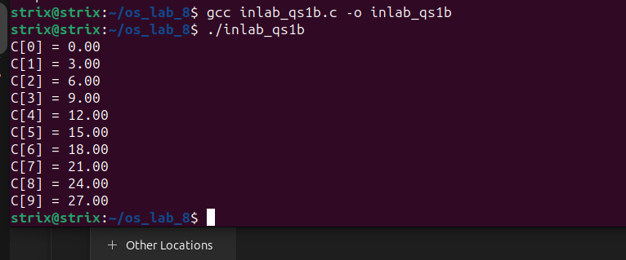

Code:

#include <stdio.h>
#include <stdlib.h>
#include <pthread.h>

#define ARRAY_SIZE 10000000
#define NUM_THREADS 10

float A[ARRAY_SIZE];
float B[ARRAY_SIZE];
float C[ARRAY_SIZE];

// Function to be executed by each thread
void *thread_add(void *arg) {
int thread_id = *((int *)arg);
int workload_per_thread = ARRAY_SIZE / NUM_THREADS;
int start = thread_id * workload_per_thread;
int end = (thread_id + 1) * workload_per_thread;

for (int i = start; i < end; ++i) {
C[i] = A[i] + B[i];
}

pthread_exit(NULL);
}

int main() {
pthread_t threads[NUM_THREADS];
int thread_ids[NUM_THREADS];

for (int i = 0; i < ARRAY_SIZE; ++i) {
A[i] = i * 1.0;
B[i] = i * 2.0;
}

for (int i = 0; i < NUM_THREADS; ++i) {
thread_ids[i] = i;
pthread_create(&threads[i], NULL, thread_add, (void *)&thread_ids[i]);
}

for (int i = 0; i < NUM_THREADS; ++i) {
pthread_join(threads[i], NULL);
}

for (int i = 0; i < 10; ++i) {
printf("C[%d] = %.2f\n", i, C[i]);
}

return 0;
}

IN lab Question 2:

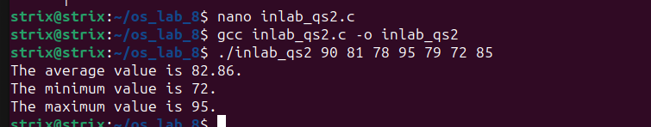

Code:
#include <stdio.h>
#include <stdlib.h>
#include <pthread.h>

#define NUM_THREADS 3

int numbers[100];
int num_count;

void *fun_avg(void *arg) {
double sum = 0.0;
for (int i = 0; i < num_count; ++i) {
sum += numbers[i];
}
double average = sum / num_count;
double *result = malloc(sizeof(double));
*result = average;
pthread_exit(result);
}

void *fun_max(void *arg) {
int max = numbers[0];
for (int i = 1; i < num_count; ++i) {
if (numbers[i] > max) {
max = numbers[i];
}
}
int *result = malloc(sizeof(int));
*result = max;
pthread_exit(result);
}

void *fun_min(void *arg) {
int min = numbers[0];
for (int i = 1; i < num_count; ++i) {
if (numbers[i] < min) {
min = numbers[i];
}
}
int *result = malloc(sizeof(int));
*result = min;
pthread_exit(result);
}

int main(int argc, char *argv[]) {
if (argc < 2) {
printf("Usage: %s <numbers...>\n", argv[0]);
return 1;
}

num_count = argc - 1;
for (int i = 1; i < argc; ++i) {
numbers[i - 1] = atoi(argv[i]);
}

pthread_t threads[NUM_THREADS];
double *average;
int *maximum, *minimum;

pthread_create(&threads[0], NULL, fun_avg, NULL);
pthread_create(&threads[1], NULL, fun_max, NULL);
pthread_create(&threads[2], NULL, fun_min, NULL);

pthread_join(threads[0], (void **)&average);
pthread_join(threads[1], (void **)&maximum);
pthread_join(threads[2], (void **)&minimum);

printf("The average value is %.2lf.\n", *average);
printf("The minimum value is %d.\n", *minimum);
printf("The maximum value is %d.\n", *maximum);

free(average);
free(maximum);
free(minimum);

return 0;
}

